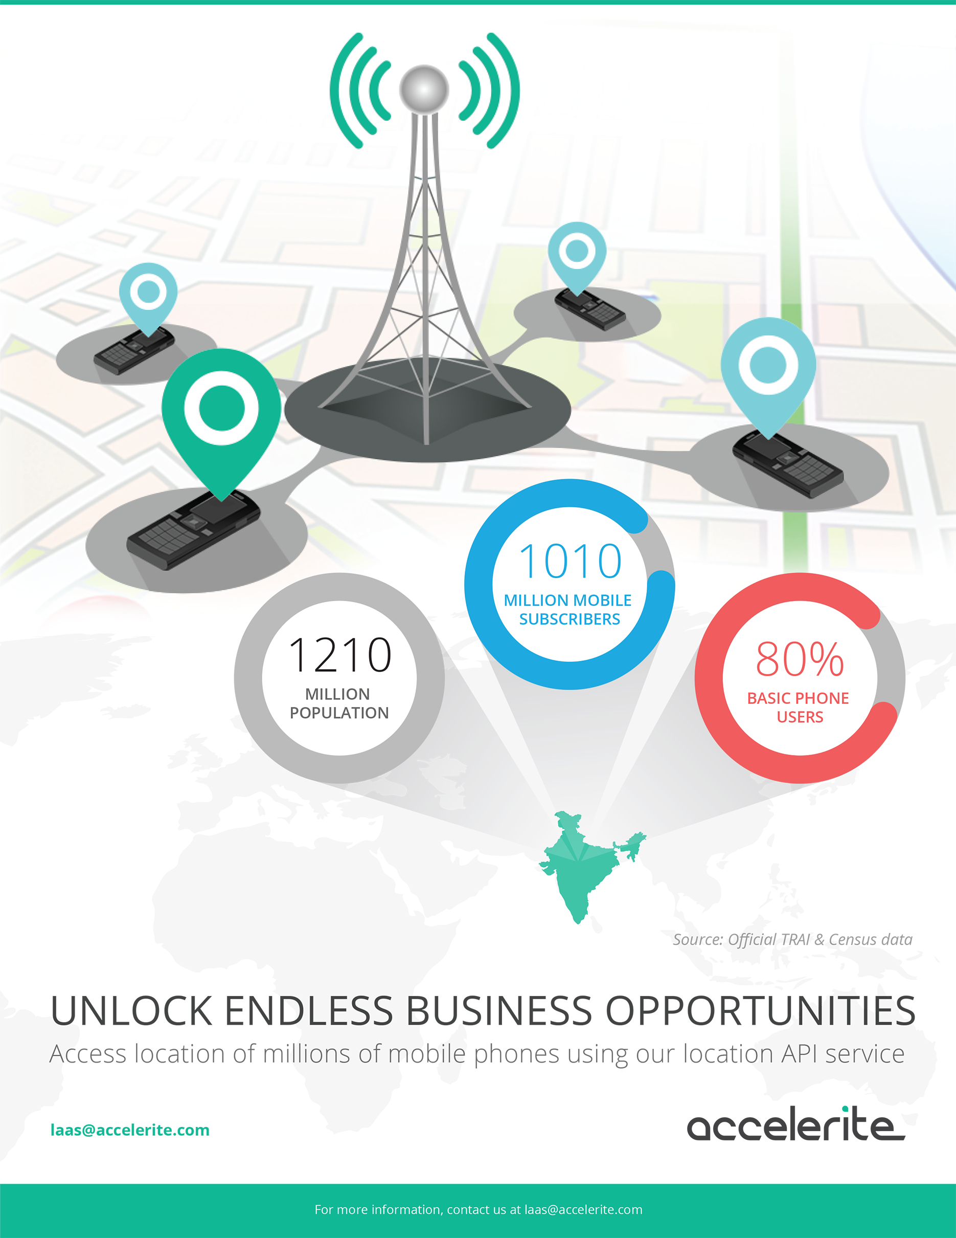

Accelerite’s
Location-as-a-Service
<Customer name>

Proposal submitted by: <>
Date: <>

Overview
Accelerite is a global product company that delivers enterprise solutions for endpoint management, cloud, and mobility to organizations of all sizes — from small businesses to Fortune 500 enterprises. Through its award-winning partner program and partnerships with HP, Dell, and CenturyLink, Accelerite helps organizations solve business-critical IT problems. Accelerite is the products business of Persistent Systems (BSE & NSE: PERSISTENT), a global leader in software product development and technology services, with 8,000 team members worldwide.
Accelerite’s Location-as-a-Service is a cloud-based service that enables API based access to location of millions of mobile phones including basic phones. This service helps you innovate new business applications and transform existing ones by making them location-aware. It unlocks a potential to create new business opportunities, serve customers better and optimize operations. Accelerite Location-as-a-service enables access to location of nearly 675 million mobile phones through our partner telecom operators across India.

Scope of Proposal
In the current scope, <customer name> is looking to utilize Accelerite’s Location-as-a-Service for <use case & scope>. Accelerite will provide <customer name> access to LaaS APIs to access location of specified mobile devices.
A detailed API guide of the service is available at http://laas.accelerite.com/.

Pricing
One time setup fees: << to be added >>

Proposal Terms and Conditions
Period | Minimum commitment  ( mobile numbers ) | Rate per mobile number per month (INR) | Remarks

Terms and Conditions:
- LaaS is a cloud based, multi-tenant platform.
- LaaS has APIs that are exposed over standard secured channels.
- As per laws enforced by Government of India, this service can only be accessed through data-center/servers hosted in India (with Indian IP address).
- A field resource can be queried for location only once in 15 minutes such that the overall load is evenly distributed across the 15 minutes interval.
- Location accuracy is dependent on location information provided by mobile operators.
- Consent from subscriber will be required as per regulatory/telecom operator guidelines.
- Limit for getting location of multiple MSISDN/mobile numbers in a single query is capped to 10 (wherever applicable).
- <customer name> and any users of the end solution will need to comply with the Legal Notices and Acceptable Use Policies as defined by Accelerite, based on what is followed by mobile operators in the country, and as communicated by Accelerite.
- Any specific additional requirements will need to be discussed separately.
- Either party may terminate the agreement with a 30 day notice.
- This proposal and budgetary quote may be revised if any of the assumptions and/or terms are invalidated/changed.
- The quoted price is exclusive of all applicable taxes.
- This proposal expires on <>.

Support terms and SLA
Severity 1 - Critical: production system is down – The product is unusable, resulting in a total disruption of work or other critical impact on operations. No workaround is available. Newly received cases will be assessed through discussions with customers to confirm that they fulfill the criteria, and may be downgraded in priority if they do not.
Severity 2 – Serious: major feature/function failure – Operations are severely restricted. A workaround is available.
Severity 3 – Medium: minor feature/function failure – The product does not operate as designed, there is a minor impact on usage, and an acceptable workaround deployed.
Severity 4 – Low: minor problem – This can be classified as a request for documentation, general information, enhancement request etc.
Response Time | Initial Response | Ongoing Response
Severity 1 | 1 hour | 2 hours
Severity 2 | 4 hours | 4 hours
Severity 3 | 6 hours | 1 business day
Severity 4 | 1 business day | 5 business days

Support Coverage
Issue | Support Timings | Support Channel
Severity 1 | 24x7, On call phone support. | Phone
Routine support | 9:00 a.m. – 06:00 p.m. IST.  On standard business working days. | Web Portal/Email

